Java Portfolio for my project “switch”.

Date: May 18, 2023

What is it: I wrote a program that’s handy when it comes to calculating scores in school.

It allows users to input certain people in a class and their scores, thus output the mean and max according to the given value.

Source code: switchcase.java

import java.util.Scanner;

public class switchcase{

public static void main(String args[]){

Scanner input = new Scanner(System.in);

System.out.println("Please type in the number of people in the class: ");

int x=input.nextInt();

String rank1="";

double mean;

int max=0, total=0;

for(int i=1;i<=x;i++){

System.out.println("Input the score of student "+i+".");

int y=input.nextInt();

total=total+y;

max=(max<y)?y:max;

if(y<=100&&y>=0){

switch((y-50)/10){

case 5:

case 4: rank1="A+";break;

case 3: rank1="A" ;break;

case 2: rank1="B" ;break;

case 1: rank1="C" ;break;

case 0: rank1="D"; break;

default:

rank1="E";break;

}//switchcase

System.out.println("The student's grade is "+rank1+".");

}//if

else

System.out.println("N/A");

}//for loop

mean=total/x;

System.out.println("Average is "+ mean +".");

System.out.println("Highest score is "+ max +".");

}//main

}//class

How it goes:

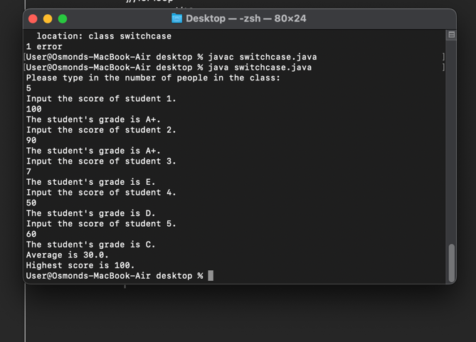

What I have learned:

1. Application of switch case.
2. Calculate the average value of given numbers.
3. If loop combining with while loop.